ENGR 1190 - Design Document

EV3 Pick and Place Robot

Submitted to:

Paul Grand

By:

Carlos Vasquez

Kevin Vo

Douglas College

August 3, 2021

**ENGR 1190 - Design project**

The main idea for this project is to show that we can use the four different types of sensors in a single program for the Lego brick. For our design project, we got inspired by modern manufacturing and autonomous robotic arms. As a result, we have decided to design a creative Pick and Place Robot, which consists of a programmable robotic system that can lift a cuboid from different locations and place it in another location or drop zone. The Pick and Place Robot involves the application of the following four sensors and two motors.

**Applications of each sensor, motor and test:**

* Touch sensor: This sensor allows the robot to stop and reset the gyro. The touch sensor is installed at the back of the arm because as the sensor gets pressed, the robot will identify the end position if no other sensor is trigger the robot restart the process and start looking for a new object.   
  + Test: To test the touch sensor, we positioned and made sure every time the arm moves the sensor will be pressed. Also, we tested that at different speed of rotation that the touch sensor would be pressed correctly.
* Gyro sensor: The gyro is used here to measure the different angles that the arm of the robot will rotate to either drop or pick up the cuboid. Alternatively, the sensor can detect any change that occur with the robot and adjust the pickup and drop speed of the motors.
  + Test: In order to test this sensor, we first needed to calibrate and made sure that gyro could identify the rate at which the angle of rotation would be implement between 0° and -90°. Multiples attempt were used to test the accuracy of the rotations in degrees.

* Light/colour sensor: the colour sensor has been programmed to identify 3 different colours such as, red, white and green. (Check the test document for more information)
* Ultrasonic sensor: Measures the distance at which the cuboid is located to improve the accuracy of the gripper and detect if there is an object to grab in the range at which the arm moves.
  + Test: We tested the ultrasonic sensor by positioning the cuboid at a different location to measure the distance between 0 to 5 cm at which the robot could detect and grab objects.
* Interactive servo motors B & C: motor B allows the right and left rotation of the arm and motor C opens and closes the grippr.
  + Test: We tested different rates of speed for the arm of the robot to ideally rotate, close and open the grabber. The perfect speed test for this pick and place robot was found to be between 5 to 15 depending on how fast we want the robot to move.

**Possible problems:**

* Not a mobile pick up place robot
* The limited range for the arm of the robot to pick or drop objects at farther distances

**Pseudocode:**

* While loop:
  + Turns on Turntable Motor B to move left, so the arm back into position
  + Waits until the Touch Sensor is pressed
  + Resets the Gyro Sensor
  + Check color sensor (example: a person’s hand)
    - If no hand was present
      * Distance sensor is going to see if there is an object within the robot reach
        + If an object was detect within robot reach

Turns on Grabber Motor C for 0.5 seconds so it closes to grab the Cuboid

Waits 1 second

Turns on Turntable Motor B at 25% power and turns to the left

Waits until the Gyro Sensor measures -90°

Turns off Turntable Motor B

Waits for 1 second

Turns on Grabber Motor C for 0.5 seconds so it opens to release the Cuboid

Waits 1 second

* + - * + Else

Go back up the program to recheck the color sensor

* + - Else
      * Stops both Motors as a safety precaution
      * Break out of while loop and end program

**Software Flowchart:**

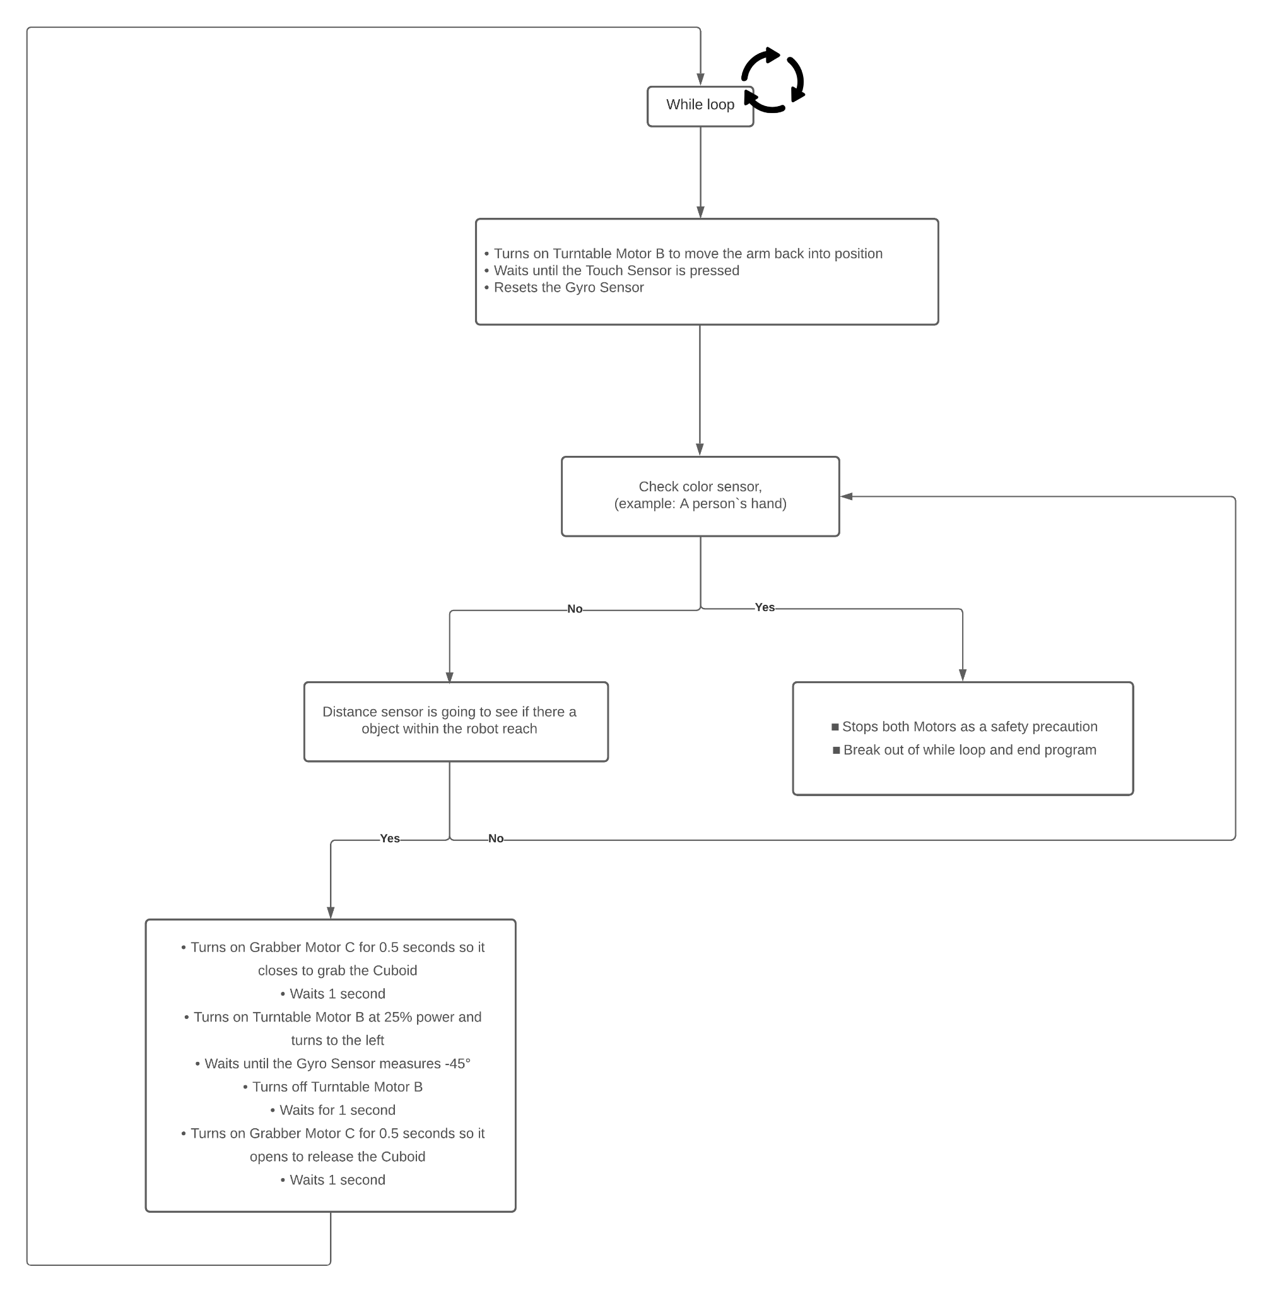

Comparison design project phase I and phase II.

For the first phase of the project we only have set the robot to do limit task like pick up an object from at fix location and drop it later in another location. This first desing helped us to understant some basics concepts that we did not consider at the beginning of the project and gave us more ideas that defenetly improved the final design. That is why for the second phase we implemented new and advace changes to the pick and place robot such us:

* Readjust the high of the ultrasonic sensor
* Readjust both the distance of the gripper and the grabbind/droppinng force
* Look for objects at any location within the range of the crane
* Add a new implementation for the colour sensor using 3 colours
* Expand the range from 0 to -45° to 0 to -90°
* Make the program smart enough to pick and place more that one object at the time

Ultrasonic mount position:

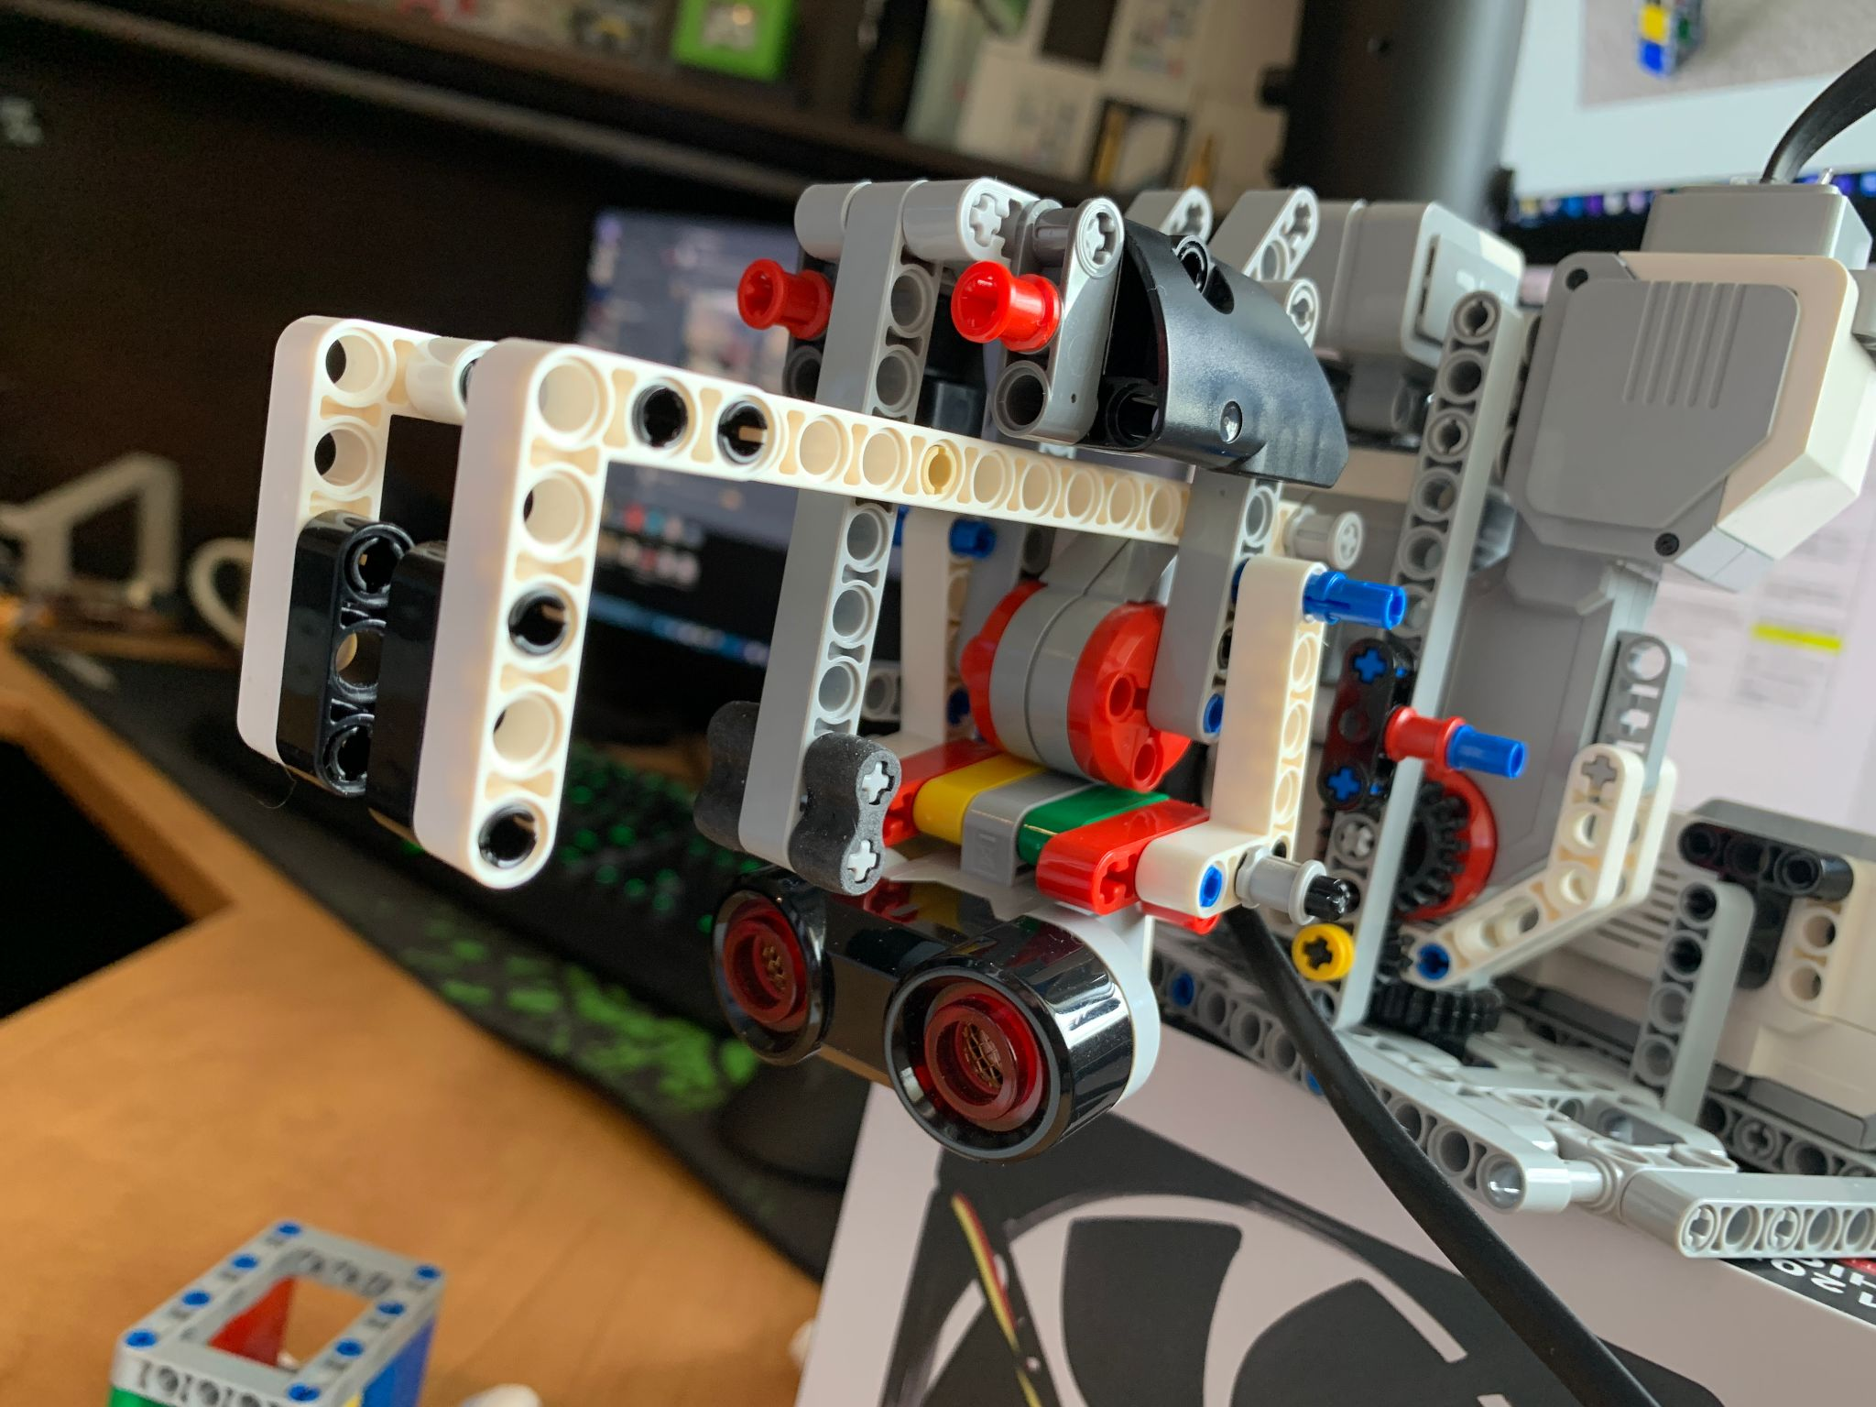

**Ultrasonic sensor**

Touch sensor position:

**Touch sensor**

Robot Side profile:

**Motor C**

**Motor B**

**Color sensor**

Robot pickup location:

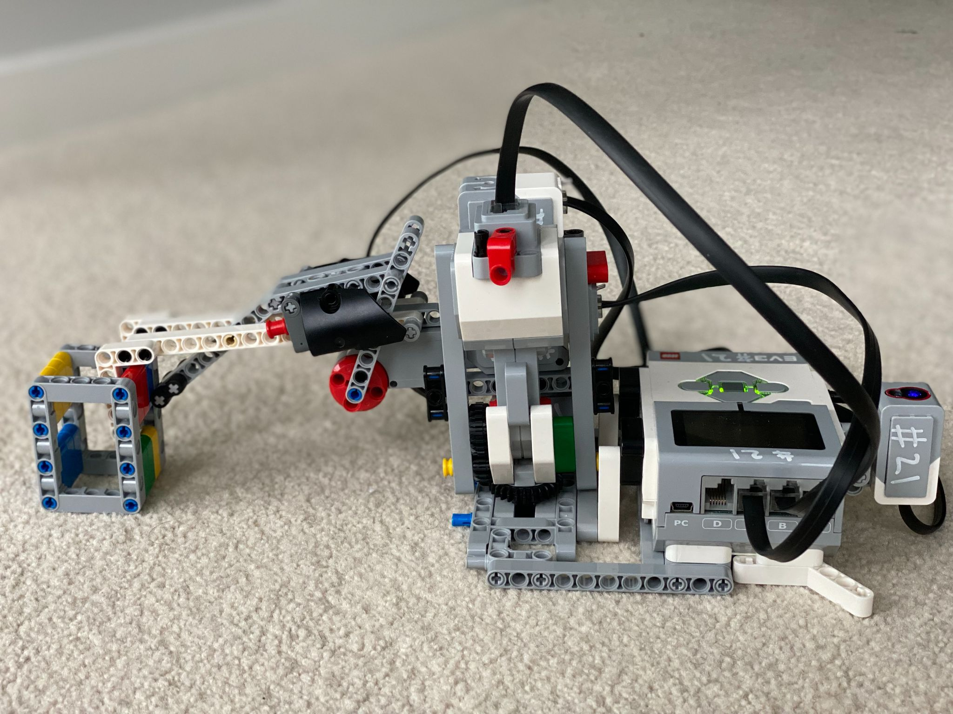

Robot in drop off position:

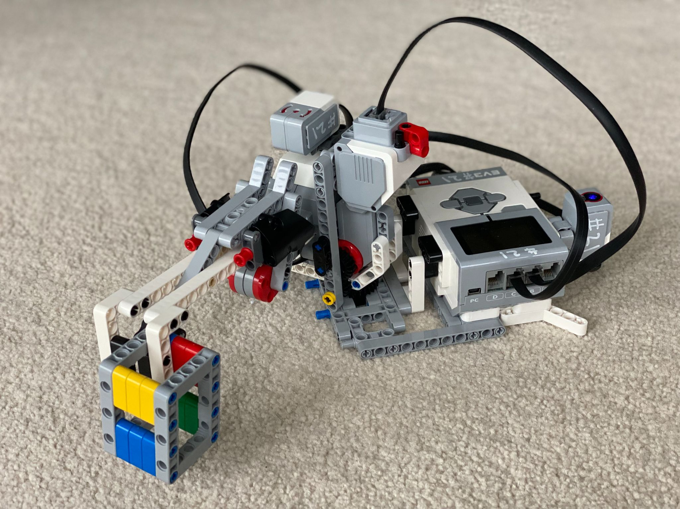

Robot Side profile:

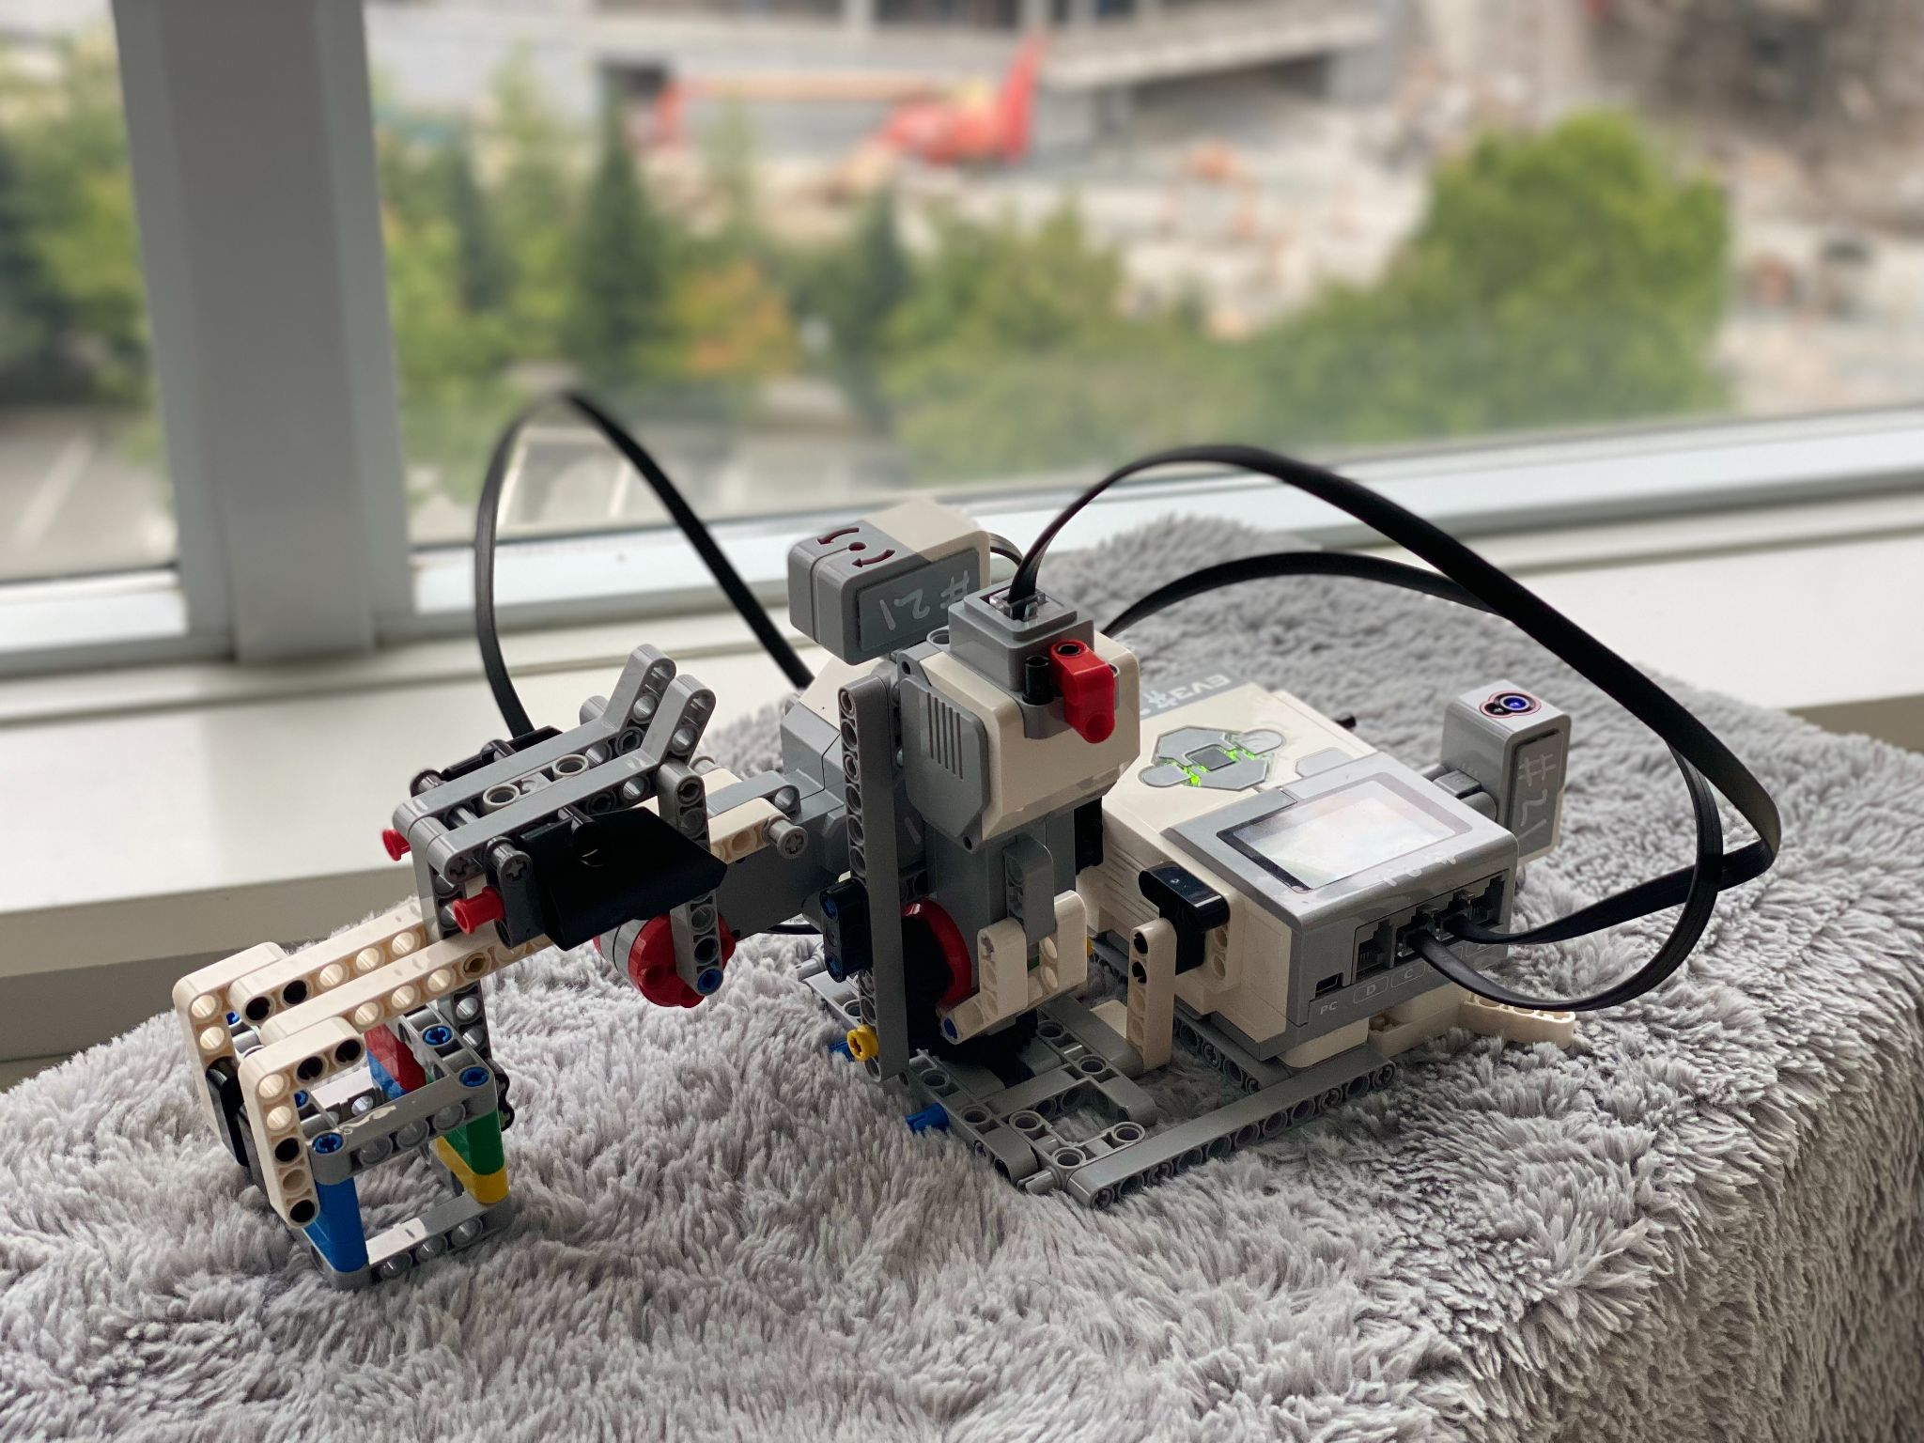

Robot Back view: